Feeling EUROPE Foundation
(Caux / IoC, July 2015)

EUROPE, A FLOWING RIVER

There is not only an ongoing debate about where the geographical centre is, but also on cultural and political issues and Europe's precise borders. The societies seem to crave to live with their individual freedom, sufficient prosperity and welfare. But Europe is a flowing river, democracy is not a lake. Each generation must be prepared to help the river to flow freely. Everything is constantly changing in the world and each generation must acknowledge that and respect the basic values of democracy. We all need to keep our democracy healthy and alive.

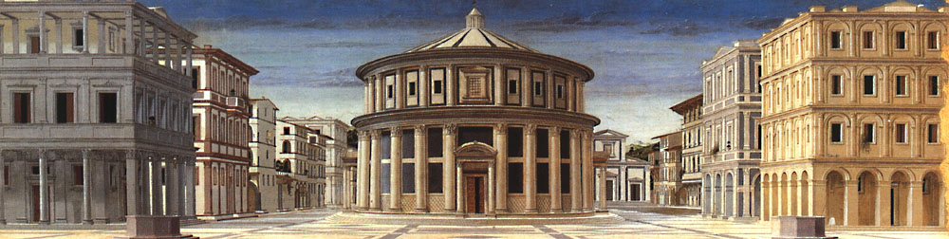
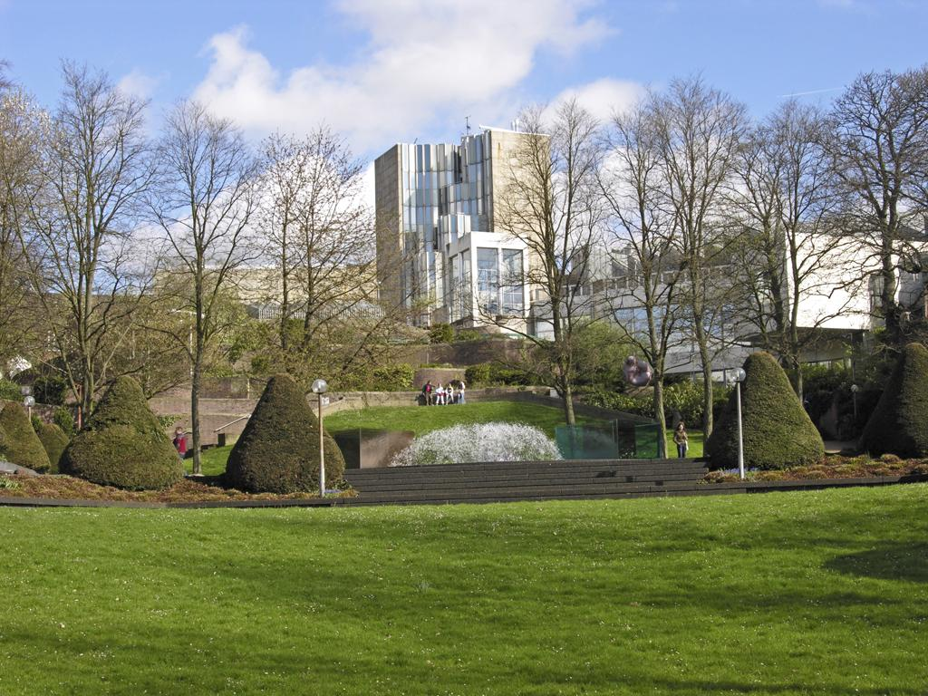
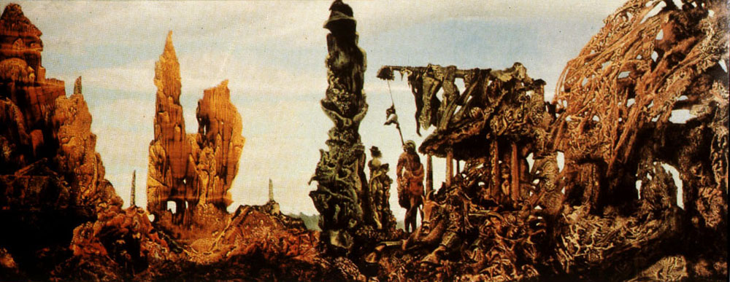
Europe has given us many diversities. When it comes to non material thoughts and practices for example the Renaissance and postmodernism (1), and to material things destructive moments of war (2), financial and economic crisis. One of the very beautiful things 70 years ago was when Adenauer and Schuman were uniting in stead of fighting, shaping Europe and reconciliating their countries. And Kohl and Buchman had a part in that. A new Europe was born. In the following decades, the grand idea of Europe has formed the European Union (3), striving to achieve the common goals aspired by the different nations.

EUROPE represents an open society and reached the following achievements: security, prosperity, peace, single market (4), a currency union (5), the Erasmus+ programme (6), the free trade agenda (TT(I)P) (7), the reform of the financial sector (8), agrees the Europe 2020 growth strategy (9) and the largest aid donor in the world. All these merits are the result of common decisions of member states and are ours, because citizens in EU member states have the European citizenship and therefore opportunity to join in order to shape.

It is within this context that the European Union is seen as the most successful integration experiment of all time and the largest area with a common prosperity in human history.

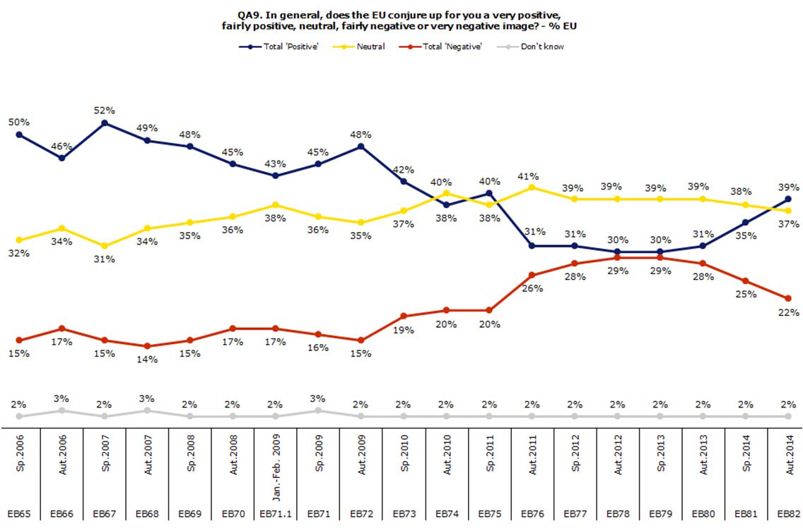
You would think everything is right with Europe. But what image does the EU conjure up? And is Europe really functioning properly? Not everybody agrees on that.
standard Eurobarometer 82 ‘Public opinion in the EU’ | the EU’s image (H II.2.2.3), Autumn ’14 (European Commission)

Europe landed in a financial, economic, political and social crisis as in a crisis of trust. From the spirit and movements derived values and virtues (10) have greatly declined in importance, acquired successes are gradually evaporating or have already been lost. European societies have forgotten the real significance of the elevations and achievements or did forget to use the password adequate. Consumerism was still pursued, which now however also is at stake. And, if not enough, there will be loss of influence on increasingly assertive becoming parts of the world, making Europe the New World now more necessary than the other way around; roles are changing. We already observe shiftings in balance of power, and disorder in large areas.

We have to defend our merits and to counteract pressures:

1 / 4

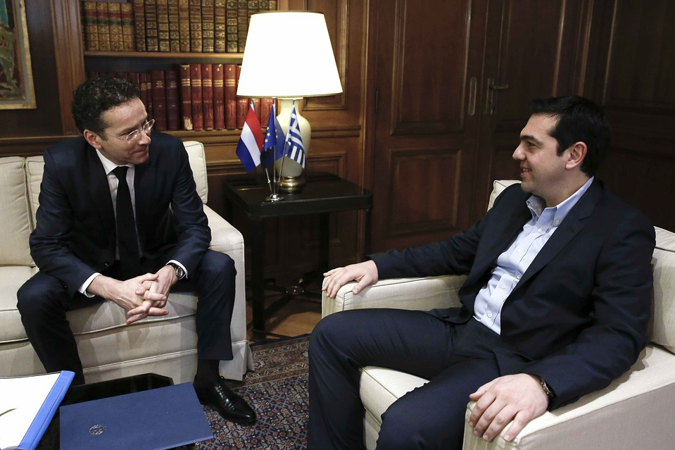
Economics & Money
Large number of questions raised not only on causes of the financial crisis, but also on the construction of the Monetary Union. But would a finished EMU / EU have prevented the eurocrisis? How to proceed further (missing) constructions in architectures? Is there political will to restrict state funding? (11) ECB has become lender of last resort, what are implications for it’s role? What to do with the Eurozone’s debt?

Europe continues to handle short term economic pressures. But it also has to handle the longer term to ensure that economies, enterprises and industry are in a strong position to strengthen multiple forces and to set GDP growth. To achieve these goals and to provide a strong economy the Economic and Monetary Union (EMU) was afterwards underpinned, job / investment plan for Europe was launched, Europe agrees '2020-strategies’.

17 April, Eurogroup President Jeroen Dijsselbloem presented at Peterson Institute for Economics the lecture 'Further Steps towards a Thriving Economic and Monetary Union’ in which he said: “We have to restart the European convergence machine process. We need discussion on political level. Economic policy coordination has to be taken by hand by European politicians in an interplay where member states are in the driving seat, and the European Commission follow to stimulate and where necessary intervenes in the process.”

Europe should help Greece away from the brink (12) and protect the eurozone from further economic and financial crisis by making social welfare-, pension-, tax-, healthcare systems, labour markets, and financial industry future proof.

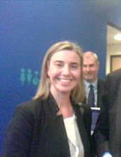

Foreign & Security policy
The failure to present a common voice on the world stage has led to Europe being sidelined in international negotiations. Far-reaching reflections are necessary because fundamental changes in relations and balances between world and regional powers are in full swing.

Europe has to answer a decisive question: do we want to participate shaping globalisation on the basis of our values and our interests – or will we leave the initiative to others and accept an outcome shaped by them? Europe need more common foreign policy (13) making goals more effective to achieve, that’s precisely one of the reasons for which the EU is founded. But is it possible to finish this without will of the leaders?

16 April, HR EEAS Frederica Mogherini presented at Leiden university the lecture ‘Europe’s global role, history and future’ in which she said: “We are able to draw on a wide range of policies for our external action: from the three d’s (diplomacy, development and defence), to migration and security. Amid the current global chaos, a new external strategy will give us a sense of direction, an ability to make choices and to prioritise. It will also give us a true sense of European ownership: a common vision.
To promote what we have, to promote opportunities for those that don't have them today and to find again hope in a better future, for us and those around us. So now more than ever we need to work together to ensure that Europe is not a fortress, or a crumbling palace of bygone glories – but truly a 'Praesidium Libertatis' for all.”

Appeasement of conflict Ukraine_Russia, counteracting terrorism, a strict but fair migration policy, and more union in European Defence (14) is at issue as part of foreign and security policy.

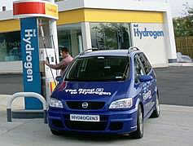
Energy
Energy is at the top of the political and economical agenda. According to the policy proposal 'Towards a European Energy Community' by Jacques Delors, Europe has lost its ability to pursue a truly common policy covering affordable access to energy, sustainable development of energy production, transport and consumption, and security of supply.

Aspects of an European Energy Community, such as integration of energy-markets, energy governance (European Agency), energy demand, collaboration and cooperation, and smart grids (15) are in further progress, which brings the creation of a needed energy union nearer.

2 / 4

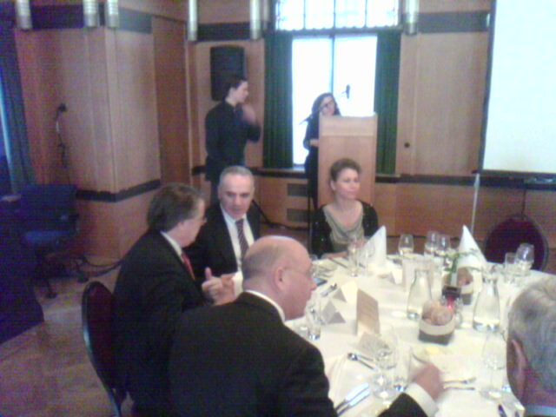
Humanitarian, institutional, and European identity
Next to recovery, we will also need ideas about the future how we want to live with each other and how we want to be governed. What culture and identity?

6 June, the founder-director of NEXUS Institute Rob Riemen wrote in the announcement for the symposium ‘Je suis Européen’:

“Who is European? What does it take to be European? Today, the European Union is largely based on the illusion that the market will unite Europe. Thus an existential crisis can arise, with a Union like a house without a foundation. What policy needs the EU to reverse the anti-European spirit and to be a confident Europe that is more than a financial and economic vehicle or a museum? A future for Europe is set in a united Europe; in the revival of a cultural-moral consciousness that transcends any kind of race and religion, an ideal of civilization which millions of citizens with passion and conviction in their own mother tongue dare say I'm a European! And will eventually say, We are European!”

To restore Euroscepticism, Europe needs to bring Greece away from the brink, a strict but fair migration policy, a modern construction for the European Union (16), strengthen member states, create perspectives for better human conditions, and build on and further spread ideas for a European identity.

From the creation of universe and man, it's to nature and us. Widely known is that all European societies (17) did contribute to our civilization. To create a new prosperous era by only restoring present disruptions will turn out not to be sufficient. We then have only straightened again disturbed affairs.
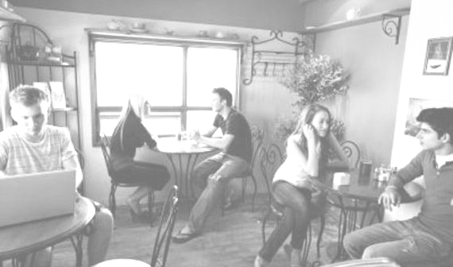

people need a gathering place to share and to create the social capital and to develop and to foster a sense and spirit of community

Europe wants to go ahead. It should let succeed values, a European spirit, work towards a strong economy & financial system, a solid foreign policy, a proper policy for energy & climate, and a considered area of liberty & security. A Europe where a European identity grows from citizens, foreign policy and security is represented by common policies, and all other aspects by societies as a whole, powered by a strong polity. Europe and the people has to show what it stands for and for which not and what it can do and what not.

These aspects asking for outlooks, and for true talks and narratives (18).

Step by step, using the concept of differentiated integration (19) and approach of multi-level governance (20), Europe is on the road to more unity. But as we know, Europe grows in looking for a form and finds its way very often due to major setbacks.

“Only together we can make sure that the freedom of opportunities we have built in the last decades can be there also for the future generations and for the present generations all around our borders” (21).

3 / 4
Feeling EUROPE Foundation, builds, informs, connects

- Renaissance: The Ideal City celebrates the values in a well ordered society, the architecture stands as a metaphore for good government. The concept dates at least from the period of Plato, whose Republics is a philosophical exploration of the notion of the ‘ideal city’. During the Renaissance interesting innovations took place in the field of geography, astronomy, chemistry, physics, mathematics, engineering and production.
Postmodern Abteiberg Museum, Mönchengladbach: Postmodernism is a late-20th-century movement in the arts, architecture, and criticism
that was a departure from modernism. Postmodernism includes skeptical interpretations of culture, literature, art, philosophy, history,
economics, architecture, fiction, and literary criticism;
- the ultimate destructive, WW-II. ‘Europe After the Rain II’, Max Ernst, an abstracted landscape that offers an apocalyptic vision of the post-war world;
- politico economic union of sovereign states in which citizens of the Member States are also citizens of the union. Decisions are not forced by unelected bureaucrats, because in reality final decisions are taken by the Council of Ministers comprising all the European Governments, with the elected European Parliament also having a role. This 'most developed example of a postmodern system’ operates through a system of supranational institutions and intergovernmental negotiated decisions by member states;
- A single market (sometimes called 'internal market') allows for people, goods, services and capital to move around a union as freely as they do within a single country – instead of being obstructed by national borders and barriers as they were in the past. European Commission / Competition which makesEU markets work better by making charges against kartels (Microsoft), dominance (GazProm), unfair use of products (Google),merge General Electric & Honeywell).
- where two or more states share the same currency, though without there necessarily having any further integration such as an Economic and Monetary Union, which has, in addition, a customs union and a single market;
- Erasmus+ is the EU Programme in the fields of education, training, youth and sport for the period 2014-2020. Education, training, youth and sport can make a major contribution to help tackle socio-economic changes, the key challenges that Europe will be facing until the end of the decade and to support the implementation of the Europe 2020 strategy for growth, jobs, social equity and inclusion;
- a type of trade bloc in which most trade barriers have been removed (for goods) with some common policies on product regulation, and freedom of movement of the factors of production (capital and labour) and of enterprise and services;
- E.g. the banking union, which establishes a single financial market, where banks are separated from their sovereigns. Supervision on financial institutions is held at European level (ECB). Additional components are a single resolution mechanism (establishing uniform rules and a uniform procedure for the resolution of credit institutions and certain investment firms) and a European deposit insurance scheme;
- digital agenda for Europe; innovation union; youth on the move; resource efficient Europe; an industrial policy for the globalisation era; an agenda for new skills and jobs and; a European platform against poverty;
- languages, literature & poetry, history, philosophy (within which ethics), religion, fine and performing arts, music, health, and sports are part of it, but also cultural values, identity, virtues, tolerance, solidarity, equality, rule of law & justice are aspects that contribute to improve well-being of people;
- using for example the position of the current account of Balance of Payments and by including a definition in the constitutions. European institutions must be able to completely remove a euro area government’s ability to borrow and in this way to avoid nationalistic isolation;
- functioning strong government agencies (cadastre), sensible financial policies (flat tax, pinmachines), sustainable economic growth (tourism, defense, digital agenda), BoP as tool to manage (eg. capital movements), substantially increasing exports (eg. field of energy),all to bring in investors. But ECB has to receive in July eur 3,5 billion and in August eur 3,2 billion and IMF about eur 600 million.
- Germany is quiet dominant: within EU on economic terms, on global level on political leadership, but Germany’s constitution limits hegemony.
- Javier Solana, former EU High Representative for the Common Foreign & Security Policy (CFSP), Secretary General of NATO and Foreign Minister of Spain, who presented present the CEP-FES Task Force Report 'More Union in European Defence', which aims to provide member states and the EU institutions with the narrative to strengthen defence cooperation in the EU, in the face of numerous emergencies in the EU’s strategic neighbourhood and ever-present security threats.
- information and communications technology to gather and act on information, such as information about the behaviors of suppliers and consumers in homes and business, in an automated fashion to improve the efficiency, reliability, economics, and sustainability of the production and distribution of electricity;
- Verhofstadt (NRC 9 May): the EU is no longer a hybrid construction of a federation and a confederation, but a medley of opt-ins, opt-outs and discounts and a litany of other exceptions. Moreover, there are fundamental contradictions (monetary union without Ministry of Finance and decent economic governance, and an internal market of 28 Member States of which only 18 belong to the Schengen area. We must come to two types of memberships of Europe: full membership and partnership;
- Greek values as freedom, truth and beauty; development of laws through Romans; faith and love from Christianity; Germanic, Slavic and Celtic cultures; the influence of secular humanism; ability to absorb societal matters; and a characteristic such as the focus on science & technology together with its ability to create and to generate new processes, materials and material combination contribute to our civilization;
- - The Seven Sages (of Greece) or Seven Wise Men (620 – 550 BC), philosophers, statesmen and law-givers who were renowned in the
following centuries for their wisdom: Cleobulus ("Moderation is the best thing." ), Solon ("Keep everything with moderation."), Chilon
("You should not desire the impossible."), Bias ("Most men are bad."), Thales ("Know thyself," ), Pittacus ("You should know which
opportunities to choose."), and Periander ("Be farsighted with everything”).
- Science and technology is rather on top as it was during the Age of Enlightenment. For our society, ideas and beliefs for a new era can, as in
earlier times, be spread around the continent by fostering an increase in literacy, and by promoting cultural and intellectual forces, one hand
with support of philosophers and local thinkers in urban coffee houses, salons, and other venues and on the other through support of modern
techniques like social media and with apps. ‘Je suis Européen’ –NEXUS Institute, June;
- a method which acknowledges that there are irreconcilable differences within the integration structure and therefore allows for a permanent separation between a group of Member States and a number of less developed integration units. DI is considered to be a tool to achieve common aims and policies in politics, social fields, economy, legislation and institutional issues to strengthen sovereignty or to enhance effective capacity;
- an approach in political science and public administration theory that originated from studies on European integration. Multi-level governance gives expression to the idea that there are many interacting authority structures at work in the emergent global political economy. It "illuminates the intimate entanglement between the domestic and international levels of authority".
- Frederica Mogherini, at Leiden University 16 April 2015 about Europe’s global role, history and future.

---

‘Feeling EUROPE’ takes position as nexus between citizens and institutions, and fosters and guides European values and affairs with the aim to advance prosperity and wellbeing. The desk adheres liberal democracy, a social market economy, and moral capitalism. The foundation acts as independent observer, delivers resonance, and operates in almost all departments of learning, science and art.

There are relations with the following centres:
- The NEXUS Institute in relation to art,culture and philosophy;
- The Jean Monnet Centre of Excellence, Leiden university Campus The Hague (the Institute of Public Aministration);
- CEPS (Center for European Policy Studies), EBN (European Movement Netherlands) NGIZ (Netherlands Society for International Affairs)
concerning European policies;
- KVS (Royal Society for Political Economy), SMO (Society & Enterprise Foundation) to stay informed on economic and financial developments;
- The ASPEN Institute and The Atlantic for insights into thoughts and beliefs all the way across the Atlantic Ocean.

4 / 4

